The México Selection by Concours Mondial de Bruxelles
"Following the Path of the Vine: el Bajío, Querétaro 2018"
awards 112 wines and 27 spirits from Mexico.

The host state, Querétaro, wins 19 medals at the event. For the second consecutive
year, Baja California remains at the top of the medal table, with 70 awards
delivered to its products.

Mexico City, Mexico. August 17th, 2018.- The results of the México Selection by Concours Mondial de Bruxelles "Following the Path of the Vine: el Bajío, Querétaro 2018" are available. The international jury awarded Silver, Gold and Grand Gold medals to wines and spirits from 13 producing states. The states that have won the most medals in the wine category this year are Baja California, Querétaro and Coahuila. The award-winning spirits come mainly from the states of Jalisco, Oaxaca, Guanajuato, Chihuahua and San Luis Potosí.

In 2018, fifteen wines received the Grand Gold Medal, compared to eleven in 2017. This year, Baja California tops the list of Grand Gold Medals, with 10 medals. Querétaro and Coahuila remain in 2nd and 3rd position, with 2 Grand Gold Medals respectively. In the spirits section, Jalisco and Oaxaca head the list of products recognized with Grand Gold Medals, with two medals each.
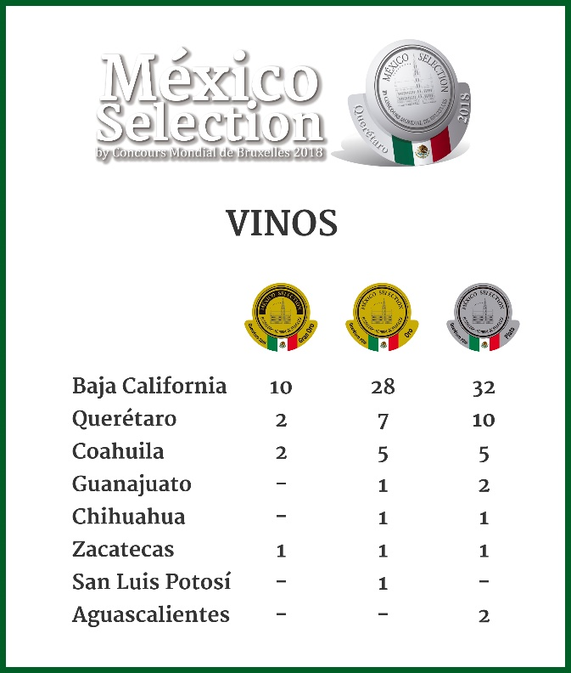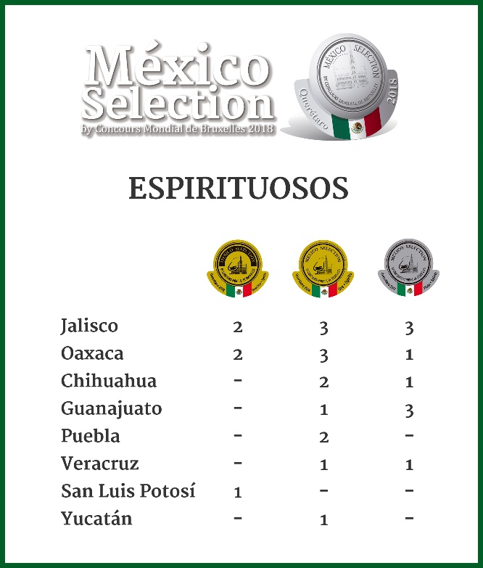
The tasters of the México Selection by Concours Mondial de Bruxelles 2018 awarded medals to 26 white wines, 75 medals to red wines, 8 to rosé wines and 3 to sparkling wines. Among the spirits, 11 medals were for mezcal, 8 for tequilas, 4 for regional liqueurs, 2 for sotol, 1 for rum and 1 for regional agave spirits.

The next host state of the México Selection by Concours Mondial de Bruxelles, Aguascalientes 2019, received two medals for its wines. 2018 is also an extraordinary year for Oaxaca; with a total of 11 awards, the state received the highest number of medals awarded this year to the spirits category.

The "Winning 2018 Wine States", the states that have obtained the highest number of awards of the México Selection by Concours Mondial de Bruxelles are Baja California (70 medals) and Querétaro (19 medals), followed by Coahuila (12 medals) , Guanajuato (3 medals), Zacatecas (3 medals), Aguascalientes (2 medals), Chihuahua (2 medals) and San Luis Potosí (1 medals).

The post-event program of the México Selection by Concours Mondial de Bruxelles includes several promotional activities for the award-winning wines and spirits, including the Ceremony for the Delivery of Medals to the Winners and Spirits of the 2nd Edition of the México Selection by Concours Mondial de Bruxelles, to be held on Wednesday, November the 21st, 2018, in Mexico City.

The results of the México Selection by Concours Mondial de Bruxelles 2018 "Following the Path of the Vine: el Bajío, Querétaro 2018" can be consulted from August 17th on the website: http://www.mexicoselection.com/

ABOUT THE MÉXICO SELECTION BY CONCOURS MONDIAL DE BRUXELLES

The 2nd Edition of the México Selection by Concours Mondial de Bruxelles was held from Augusta 9 to 11, 2018, in Santiago de Querétaro, Mexico. 420 wines and spirits from 16 producing states competed for a distinction. A total of 34 judges, from 8 countries, blindly tasted and scored wines and spirits. The next Mexico Selection by Concours Mondial de Bruxelles will be held in the State of Aguascalientes, in 2019. The Mexico Selection by Concours Mondial de Bruxelles aims to highlight the characteristics of quality Mexican wines, in Mexico and the world, while promoting healthy competition to raise the qualitative levels, and attract international opinion leaders to disseminate, in their respective media and communication channels, information related to the achievements of Mexican viticulture and the national spirits industry.

Revelation Wines México Selection by CMB 2018

Revelation | Wine | Winery | State | Producing Area
2018 Revelation Red | Viñedos de la Reina Cabernet Sauvignon 2015 | Viñedos de la Reina | Baja California | San Vicente Valley
2018 Revelation White | Tierra Adentro Sauvignon Blanc 2017 | Campo Real Vinícola SAPI de CV | Zacatecas | Trancoso
2018 Revelation Rosé | Rosea 2017 | Franquiciatarios Unidos Il Cuore Italiano SA de CV | Baja California | Guadalupe Valley
2018 Revelation Sparkling | Viña Doña Dolores Brut Rosé | Freixenet de México, S.A. de C.V. | Querétaro | Ezequiel Montes

Revelation Spirits México Selection by CMB 2018
Revelation | Spirit | Distillery | State | DO
2018 Revelation Mezcal | El Buen Comarro Mezcal Ancestral | El Buen Comarro Mezcal | San Luis Potosí | Mezcal
2018 Revelation Tequila | Realeza Mexicana Añejo | Selectos De La Tierra Azul, S.A De C.V. | Jalisco | Tequila
2018 Revelation Liquor | Crema de Sotol La Promesa | Sotol La Promesa | Chihuahua | Sotol

Press contact:
Marcelo Confalonieri, marcelo.confalonieri@vinopres.com, T: +32 478 21 27 32
Carlos Borboa, mexicoselection@vinopres.com, T: +52 (1) 55 4577-2577

